Parents of Transition-Aged Children with Significant Disabilities Needed for Research Study

Greetings! My name is Kimberly Patton and I am a doctoral student in Special Education at the University of Illinois at Urbana-Champaign. My advisor, Dr. Meghan Burke, and I are looking for participants for an exciting research project that focuses on parent and teacher perspectives of the transition to employment for individuals with significant disabilities. Below, we provide a description of the study.

Title of the Project: Examining Parent-Teacher Agreement Regarding the Transition to Employment Process

About the Project: As a participant, you will complete an online survey that should take about 20 minutes to complete. At the end of the survey, we will also ask you to provide contact information for your child’s special education teacher. Our goal is to determine the extent that parents and teachers agree about their views of the transition to employment for individuals with significant disabilities. We believe that the information you provide through this study will help to inform transition-related practices involving individuals with significant disabilities, their families and their teachers.

Potential Participants, please consider participating in this study if:
(a) You are the parent or guardian of a transition-aged youth (i.e. between the ages of 14.5-22) with a significant disability (i.e., intellectual disability, autism, or multiple disabilities) who also participates in the alternate assessment,

(b) You are willing to identify and provide contact information for the special education teacher for their child, AND

(c) Your child attends school in the state of Illinois

If you choose to complete the survey, you will be asked to enter your email to receive a $10 Amazon gift card in appreciation of your participation in the research study. For more information, please contact Kimberly Patton (kagentry@illinois.edu).

Thank you,

Kimberly Patton, M.Ed

To begin the survey, click here: https://illinoislas.qualtrics.com/SE/?SID=SV_56Ltk4HYBQ7IlpP

Or follow this QR code on mobile devices:
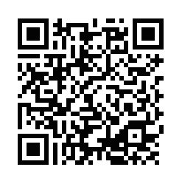
Thank you for considering participating in our project!

